UKS2 What is holiness for Jewish people: a place, a time, an object or something else?
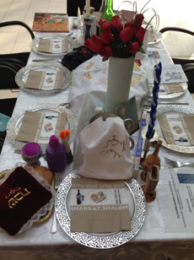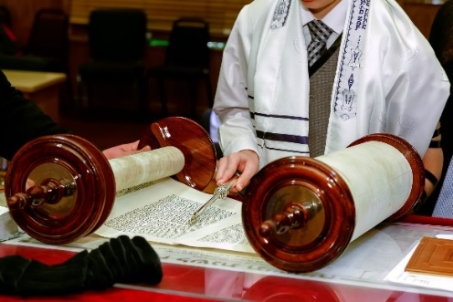
What should we know?
Jewish people believe:
- God is holy.
- God gives commands to his people to make them holy, to live a holy life and keep to a holiness code.
- God’s name itself is holy. Jewish people use an alternative for the word God e.g. Ha shem – the name, or G - D.
- Shabbat is a holy time.
- Being Barmitzvah/Batmitzvah does not make someone holy but it makes a Jewish person responsible to God for their religious lives.

Prior learning
Mitzvahs (good deeds) are important.
Shabbat is a day of rest.
At New Year God gives people a chance to put things right.
The Torah is an important book.
The Exodus story.
There is a covenant between God and the Jewish people.

What should we be able to do?
Explain what the burning bush story in Exodus teaches about holiness.

Explain in what way Shabbat is holy and how Jewish families mark its beginning and ending.

Give examples of what the Torah says about living a holy life.

You shall be holy, for I the Lord your God am holy. Leviticus 19 v.2

What words should we understand and be able to use?
Ner Tamid | The eternal flame, it burns in front of the Holy Ark in a synagogue as a reminder of God’s presence. | Bar Mitvah  Bat Mitvah | Children become responsible for their own religious lives. Boys become ‘bar mitzvah’ at 13. Girls become ‘bat mitzvah’ at 12.
Shabbat | The Jewish day of rest (Saturday).

