LKS2 How does a Muslim show their submission and obedience to Allah?
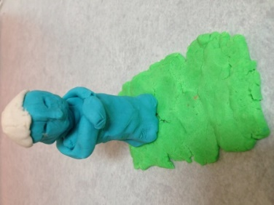

What should we know?
That submission is about recognising that Allah is to be obeyed at all times.
That Muslims believe:
- That Allah is the one true God; the most important being in the universe.
- That Allah should be obeyed in every way and Muslims trust him to tell them the right thing to do.
- That praying five times a day helps them to remember to submit to Allah in all they do.
Prior
learning
The importance of the names ‘Allah’ and ‘Muhammad’ to Muslims.
Stories about Muhammad.
The different names of Allah e.g. the doer of good, the generous, which show what a Muslim believes about God.

What should we be able to do?
Explain how a Muslim responds when hearing the Adhan.
Explain that Muslim means ‘one who ‘submits’ or who willingly does what God wants them to do.
Explain a Muslim learns from the story of Bilal and the first call to prayer to submit to Allah.
Describe some things Muslims do when they get ready for prayer and how the physical actions show submission to Allah.
Understand that saying the Bismillah reminds Muslims that Allah is involved in everything.

Praying five times a day

Prayer mat
Whispering the call to prayer

What words should we understand and be able to use?
Submission | For a Muslim this means obeying Allah as creator of all. | Adhan | The Adhan is the Muslim call to prayer performed in Arabic. It announces the beginning of a set period of prayer.
Bismillah | This means ‘in the name of Allah.’ The first words in their holy book. Muslims says this before starting anything. | Muezzin  (mu’adhin) | One who calls the adhan, five times a day, by a muezzin from the top of a minaret (tower on the mosque).
Salat | The ritual prayer of Muslims, performed five times daily in a set form. | Muslim | A follower of Islam. One who submits to Allah.

