LKS2 What do Christians mean when they talk about the Kingdom of God?
What should we know?
Remember the Kingdom of God is not a place – it is present whenever people live God’s way.
Christians believe:
- In living God’s way. Jesus summed this up with the Golden Rule: ‘In everything do to others as you would have them do to you.’
- God is King.
- The Bible and the parables of Jesus teach the right way to live.
- The Lord’s Prayer is an important prayer because it is about wanting God’s kingdom to come. Christians want to be part of spreading God’s kingdom on earth.

Prior learning: Christians are followers of Jesus, the saviour of the world. He died but came back to life.
A cross reminds Christians of his sacrifice, but is also a sign of commitment and God’s love.
Jesus told parables to teach about God.
Christians pray to God and worship him in different ways. God offers us forgiveness.
The Holy Spirit reminds Christians God is always with them.

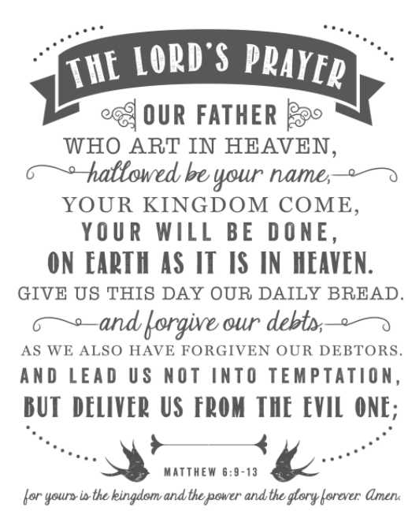
What should we be able to do?
Be familiar with the Lord’s Prayer and understand it was a prayer Jesus taught.
Describe how Christians believe Jesus is king and want to follow his way of life.
Recall at least one parable Jesus taught about God’s Kingdom.

T
Thgehe

What words should we understand and be able to use?
Parable | A parable is a story with a special meaning. | The Lord’s Prayer | The prayer Jesus taught his followers.

