LKS2 How does the teaching of the gurus move Sikhs from dark to light?
Guru Granth Sahib
Ik Onkar – one God.
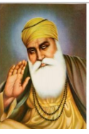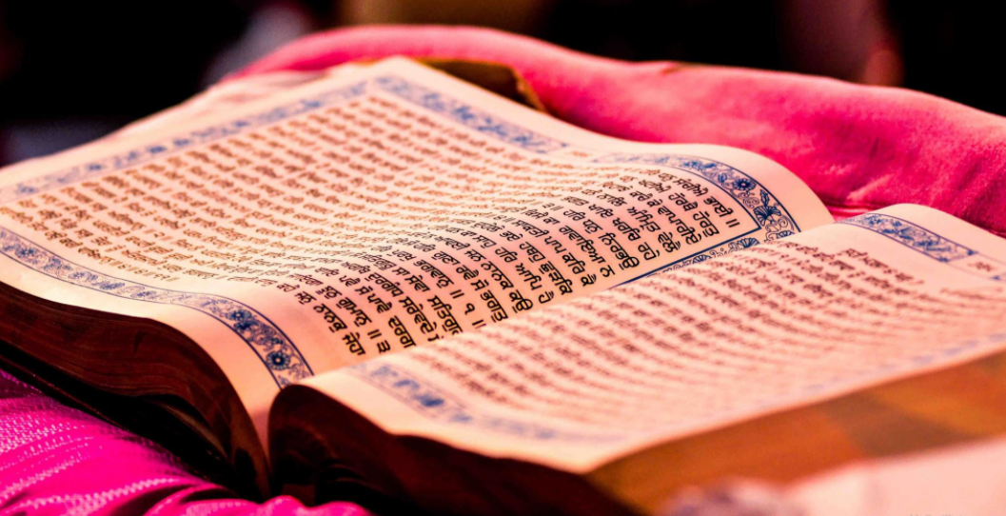
What should we be able to do?
Understand that Guru means teacher and the purpose of a Guru to share the light of God.
Describe what a Sikh might learn from stories of Guru Nanak.
Understand the significance of Ik Onkar as representing the Sikh belief in one god.
Describe how and why Sikhs show the Granth the respect due to a living guru and how this is like or different from how other holy books are treated.
Understand how a Sikh will listen to the true Guru through chanting and meditating.
What should we know?
A Guru is a teacher who gives guidance from God.
Sikhs believe:
- In one God ‘Waheguru,’ the most wonderful teacher.
- That no one religion is the only true way to Waheguru. We are all children of God.
- Guidance from God came to humans through ten Gurus.
- Guru Nanak was the first Guru. He wanted to teach people how they should live their lives and try to bring them into the light.
- The Guru Granth Sahib continues to lead those who choose to follow its teachings from Darkness to Light. Sikhs are encouraged to listen and meditate on its words.
- Repeating ‘Waheguru’ focuses the mind and helps you know God better.

Guru Nanak - All that matters is to love God in your heart and to worship God with all your soul.

What words should we understand and be able to use?
Sikhism | Based on the belief in One God, the Sikh religion recognizes the equality of all human beings. Sikhism is more properly known as SIKHI; Sikhism is a western term. | Guru Nanak | The founder Guru of Sikhism regarded as the embodiment of Divine Light.
Sikh | Sikh (pronounced ‘seek’ in Britain but ‘sic’ is more accurate) means learner, disciple or follower of the Gurus. | Guru Granth Sahib | The final Sikh Guru in the form of a book of hymns and prayers written by the gurus. Given the same respect as a living human Guru.
Guru | For Sikhs this term means a teacher who gives guidance from God. The word Guru is composed of two terms: GU means darkness and RU- means Light. A guru is Human in form, divine (of God) in spirit. | Waheguru | God has many names in Sikhism and Waheguru is probably the most important and most common

