KS1 Why do Jewish families say so many prayers and blessings?
What should we know?
Jewish people:
- Say prayers and blessings to God because it reminds them how great God is.
- Say thank you to God for all he provides.
- Have a day of rest each week called Shabbat.
- Pray at both home and the synagogue.
- Sometimes wear special clothes.
Prior
learning
Jewish people believe good deeds are important.

HELP others in need.
WELCOME others.
GIVE money to help other people
CARE for the world.

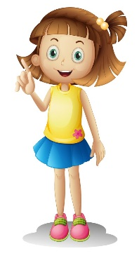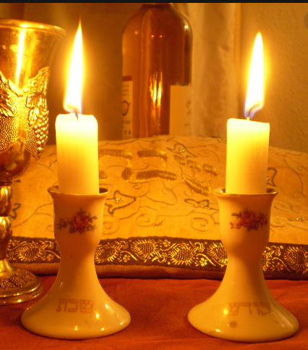
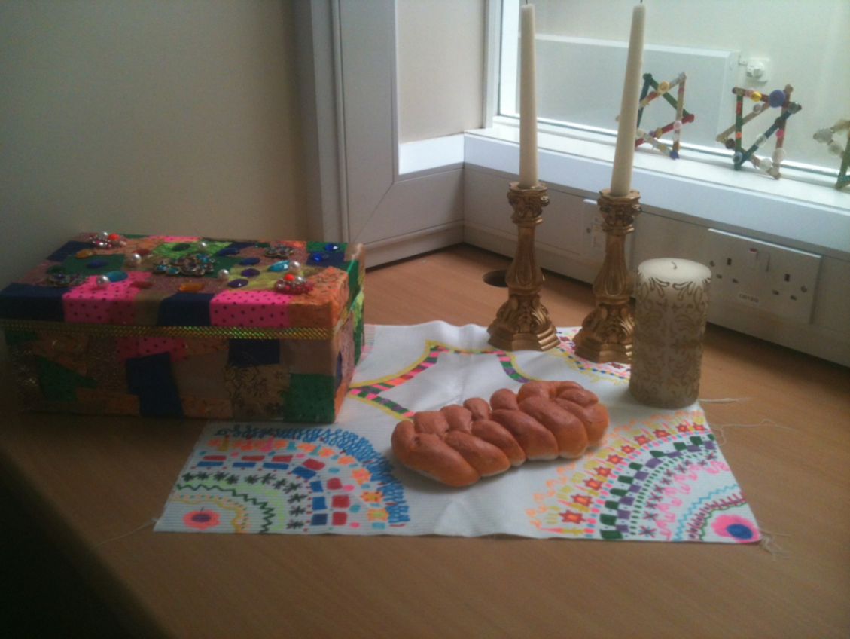
What should we be able to do?
Recognise a Jewish sukkah.
Recall when a Jewish person might say a special blessing.
Describe what is special about Shabbat.
Describe what some Jewish people wear when they pray.

‘Blessed are you, Lord our GOD, King of the Universe’


What words should we understand and be able to use?
Sukkah | A special hut built during the festival Sukkot. | Synagogue | Known as the ‘House of Prayer,’ a Jewish community house.
Shabbat | The Jewish day of rest. | Tallit | Jewish prayer shawl.
Kippah | 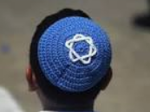  A head covering for Jews. | Havdalah ceremony | 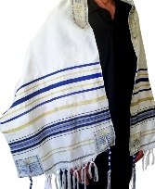  marks the end of Shabbat.

