KS1 Why do Christians trust Jesus and follow him?
Prior learning:
Jesus is the saviour of the world. He died at Easter but came back to life.
Jesus told parables to teach about God.
Christians pray to God and worship him in different ways.
The Holy Spirit reminds Christians God is always with them.

What should we be able to do?
Describe how a Christian follows Jesus and how they try to copy his example.
Explain that Christians read the Bible.
Know some Bible stories.
Describe what a Christian might ask God for.

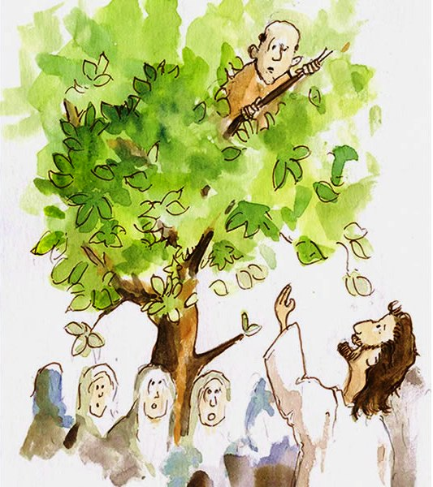



What should we know?
Christians put their trust in Jesus. They choose to listen to him and follow his example.
The Bible contains stories of people who followed Jesus which we can learn from.
Christians ask God to help them follow Jesus more closely.
Some Christians say a creed which explains what they believe.
All Christians try to listen to the words of the Bible to help them follow Jesus. Or they look at people who have been good and brave Christians and try to be like them.

T
Thgehe

What words should we understand and be able to use?
Trust | To ‘trust’ someone is about having ‘faith’ in them. | Creed | A statement of belief.

