KS1 Why was Jesus given the name ‘saviour’?
Prior learning:
God is a VIP.
Jesus is God’s son. He told parables to teach about God.
Everyone is welcome into the Christian family.
Christians pray to God and worship him in different ways.
The Holy Spirit reminds Christians God is always with them.

What should we be able to do?
Remember the Annunciation story.
Recognise an advent calendar or candle.
Recall one of the stories about Jesus as a baby.
Describe Jesus as a saviour or rescuer.
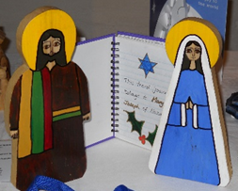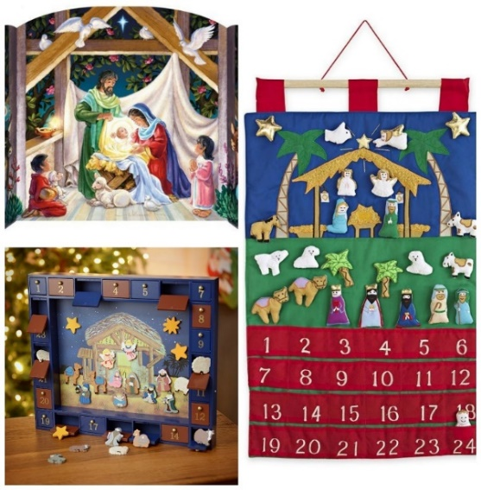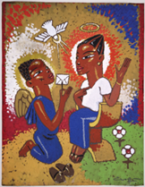
What should we know?
Christians believe:
- God decided to show the world how much he loved us by coming to earth as the baby Jesus. This was a wonderful gift.
- Jesus is the saviour and rescuer of the world. He shows people the way to God.
- Advent is a special time of waiting to celebrate the ‘coming’ of Jesus.

T
Thgehe

What words should we understand and be able to use?
Advent | The four Sundays and weeks before Christmas. | Annunciation | The story in the Bible when the Angel Gabriel told Mary she was going to have a baby.

