KS1 Why do Christians pray to God and worship him?
What should we be able to do?
Use the right words to talk about Christians praying at mealtimes e.g. grace, God, amen.

Understand that Christians pray and worship God in different ways.

Recognise at least some of the words from the Lord’s’ Prayer.
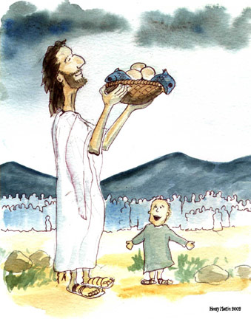

What should we know?
Christians pray in different ways.
Christians go to church to tell God how great he is.
Christians believe:
- God is with them, listening when they want to talk to him.
- God is like the best kind of parent. They can talk to him about everything.
- Jesus taught his disciples to pray by teaching them The Lord’s prayer.

Prior learning Christians believe:
God is a VIP.
Jesus is God’s son. He told parables to teach about God.
Everyone, and our world, is precious to God.
Babies are welcomed into the Christian family.

What words should we understand and be able to use?
Prayer | Talking with and listening to God. | Worship | Telling God how great he is.
The Lord’s prayer | A special prayer Jesus taught his disciples.

