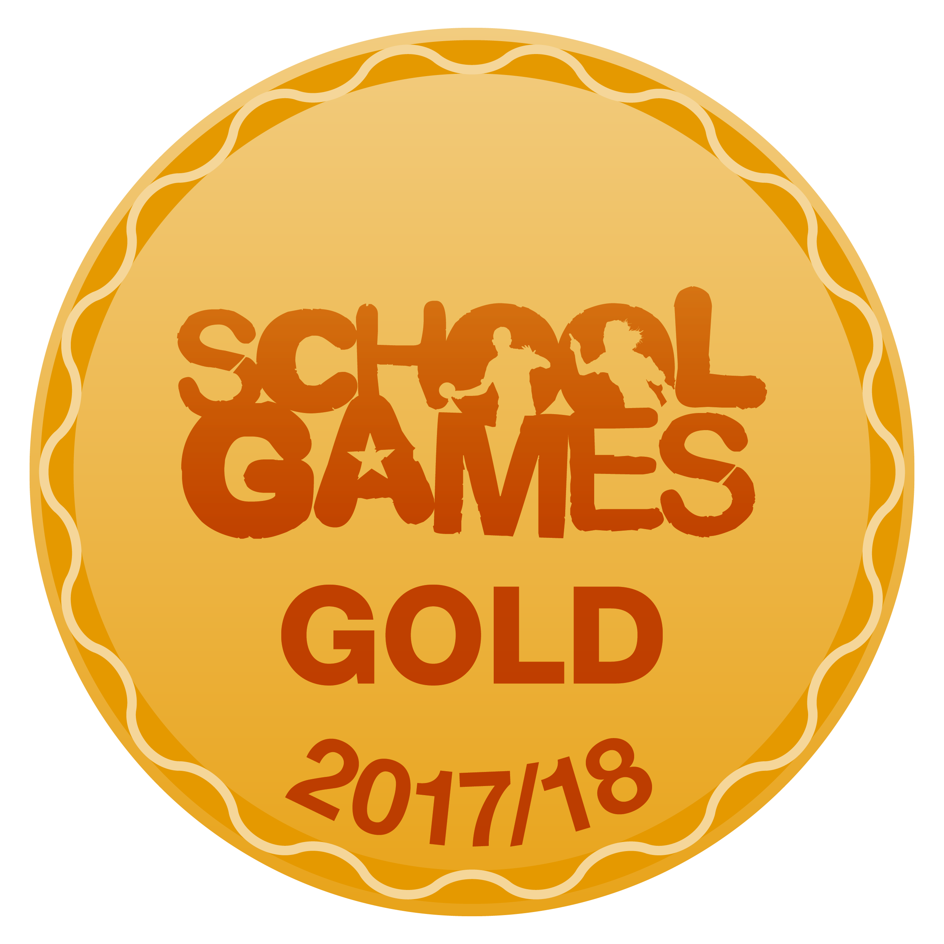
We are delighted to announce that we, Hollybush School, have achieved the School Games Gold Level Mark Award for the 2017/18 academic year.
The School Games Mark is a Government led award scheme launched in 2012, facilitated by the Youth Sport Trust to reward schools for their commitment to the development of competition across their school and into the community, and we are delighted to have been recognised for our success.
We are extremely proud of our pupils for their dedication to all aspects of school sport, including those young volunteers, leaders and officials who made our competitions possible.
As part of our application, we were asked to fulfil criteria in the areas of participation, competition, workforce and clubs, and we are pleased that the hard work of everyone at our school has been rewarded this year.
A special thanks to:
All of the staff at Hollybush School, Mat Ogilvy our PE specialist, outside agencies who support us in our CPD and inspire the children with their knowledge and professionalism, and in particular the HWSSP who provide us with sporting opportunities suitable for all children. And finally, the children whom we are extremely proud of and the parents/carers who we are grateful for their continual help and support.
We look forward to applying once again in 2019!

