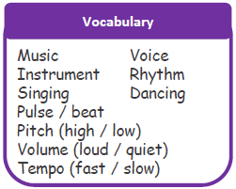
Hollybush EYFS Knowledge Organiser
Building blocks for learning

Communication and language | Listening, Attention and Understanding:  Recognise and respond to many familiar sounds.  Show an interest in play with sounds, songs and rhymes.  Join in with repeated refrains and anticipates key events and phrases in rhymes and stories.  Develop listening skills in a social setting.  Develop short term auditory memory.  Speaking:  Use intonation, rhythm and phrasing to make the meaning clear to others.  Begin to ask questions about why things happen and I am beginning to give explanations.
Literacy | Reading  Have some favourite stories, rhymes, songs, poems and share them with an adult, peer or look at them alone  Join in with rhyming and rhythmic activities  Fill in the missing word or phrases in a known rhyme, story or game  Say and perform action to a familiar nursery rhyme  Begin to recognise language patterns in stories, poems and other texts (repeated phrases, rhyme and alliteration)  Say the rhyming word at the end of a familiar rhyme  Recognise rhyme in spoken words by clapping and tapping syllables in words
Expressive Art and Design | Being imaginative and expressive  Exploring my voice and enjoying making sounds  Join in with songs and rhyme, making some sounds  Make rhythmical and repetitive sounds  Anticipate phrases and actions in rhymes and familiar sounds  Join in and take part in action songs  Listen with increased attention to sounds

Big Question – what is rhythm and rhyme?

When we listen to rhyme, poems and songs with rhythm or repetition it helps our brain to develop so we can learn to read and write
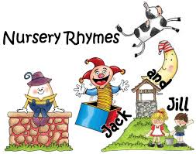

Familiar Songs
– Children will sing songs that they are familiar with including nursey rhymes, birthday song, hymns, Christmas
carols and simple pop songs.
Instruments
– Children learn that musical instruments are used to make music and can be made out of objects such as spoons, pots, tubing, and pasta. They will be introduced to drums, glockenspiels, maracas, triangles, cymbals, tambourines, and bells as well as listening to music including violin, piano, trumpet. They learn how to hold and use percussion instruments and investigate the sounds that they make. They use these instruments to play along to the beat of the music and to tap out simple rhythms. They can change tempo, volume and pitch.

